**Sales Table**

**1.Find total quantity sold by each salesperson.**

select Salesperson,sum(Quantity) as totalQuantity from Sales group by Salesperson having sum(Quantity);

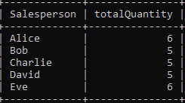

**2.Find salespersons who sold more than 5 items in total.**

select Salesperson,sum(Quantity) as totalQuantity from Sales group by Salesperson having sum(Quantity)>5;

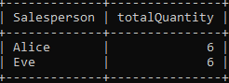

**3.Find number of products sold by each salesperson.**

select Salesperson,sum(Quantity) as totalproducts from Sales group by Salesperson having sum(Quantity);

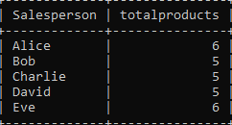

**4.List regions where total sale amount exceeded $1000.**

select Region,sum(SaleAmount) as totalSaleAmount from Sales group by Region having sum(SaleAmount)>1000;

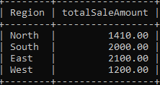

**5.Show salespersons who made more than 2 sales transactions.**

select Salesperson, count(*) as salestransaction from Sales group by Salesperson having count(*)>2;

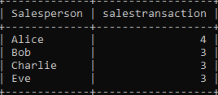

**6.Find total sale amount by product, and show only products that made over $500 in sales.**

select product, sum(saleamount) as totalsaleamount from Sales group by product having sum(saleamount)>500;

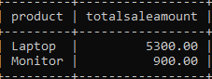

**7.Show the total quantity sold of each product in each region.**

select Region,Product, sum(Quantity)as totalquantity from Sales group by Region,Product;

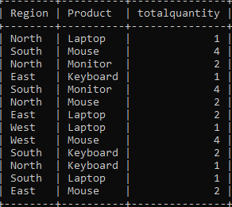

**8.Find salespersons who sold more than 1 type of product.**

select Salesperson,count(product) as product from Sales group by Salesperson having count(product)>1;

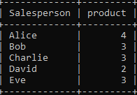

**9.Find the average quantity per product sold per region, where the average is greater than 1.**

select region,product,avg(quantity) as avg_quantity from Sales group by product,region having avg(quantity)>1;

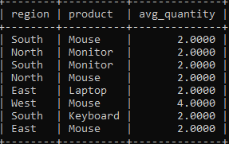

**10.Show salespersons whose total sale amount is between $500 and $1500.**

select salesperson, sum(saleamount) as total_sale from sales group by salesperson having sum(saleamount) between 500 and 1500;

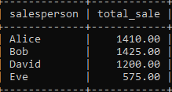

**11.List top-performing products (more than 3 units sold in total).**

select product,sum(quantity) from sales group by product having sum(quantity)>3;

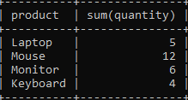

**12.List salespersons who sold laptops.**

select salesperson,product from sales where product='laptop';

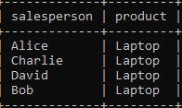

**13.Find total sale amount per salesperson per region, only where it exceeds $500.**

select salesperson,region , sum(saleamount) as total_sale from sales group by salesperson , region having sum(saleamount)>500;

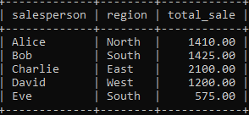

**14.Find salespersons who sold at least 2 different products in a single region.**

select salesperson,region from sales group by salesperson , region having count(distinct product)>=2;

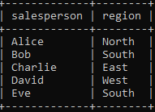

**15.Find products that were sold in more than one region.**

select product from sales group by product having count(distinct region)>1;

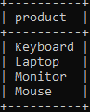

**16.Show total number of sales per product and hide products with fewer than 2 sales.**

select product,count(*) as total_sales from sales group by product having count(*)>=2;

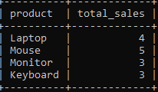

**17.Find region-wise total quantity sold by each salesperson.**

select region, salesperson, sum(quantity) as total_quantity from sales group by region,salesperson;

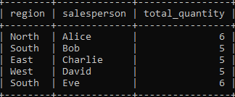

**18.Find salespersons who made more than 3 transactions and total sales amount is over**

**$1000.**

select Salesperson, count(*) as salestransaction ,sum(saleamount) as total_saleamount from Sales group by Salesperson having count(*)>3 and sum(saleamount)>1000;

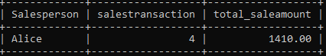

**19.Find average sale amount per region and show only regions with average above $200.**

SELECT Region, AVG(SaleAmount) AS avg_sale_amount FROM Sales GROUP BY Region HAVING AVG(SaleAmount) > 200;

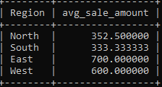

**20.List regions and products where more than 3 units were sold.**

SELECT Region, Product, SUM(Quantity) AS total_units_sold FROM Sales GROUP BY Region, Product HAVING SUM(Quantity) > 3;

